**History of Java:**

* Released mid 1995 by Sun Microsystems
* Designed to be:
  1. A powerful, full-featured, OO development language
  2. Easy to learn
  3. Used on any platform
  4. Support development of applications for networked environments
* **Powerful** 
  1. Class library
     + Hundreds of prewritten classes
     + Provide methods to accomplish various tasks
* **OO**
  1. Implements OO concepts
  2. Encourages good software design
* **Simplicity** 
  1. Keywords
     + Have special meaning in the language
     + Used in writing statements

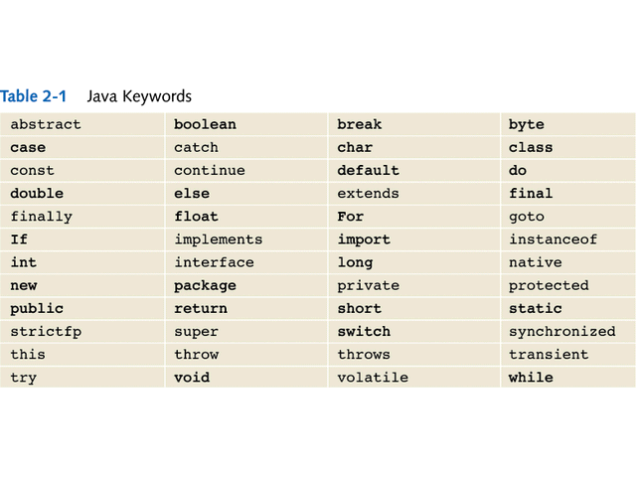

* **Portability** 
  + Programs can be written and compiled once, then run on different platforms
    - Important for internet applications (applets)
  + Achieved by using:
    - Bytecode
      * Produced when a Java program is compiled
    - Interpreter (Java Virtual Machine – JVM)
      * Execution environment for bytecode on each platform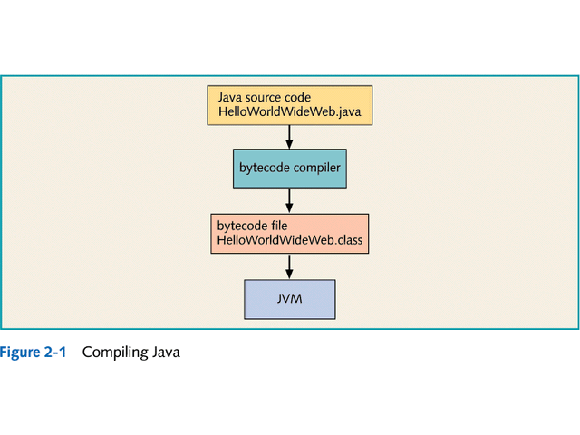
* **Development environments**
  + Java Development Kit
    - Available free from Sun Web site: https://www.oracle.com/java/index.html
    - Includes: compiler JVM and prewritten classes
  + Integrated Development Environments (IDEs) : Eclipse
    - Provide:
      * Sophisticated editors
      * Debugging tools
      * Graphical development tools
* Branches:
  1. JAVA SE – for Desktop Applications
  2. JAVA EE – for Web Applications
  3. JAVA ME – for Mobile Applications
  4. JAVA DB – for Derby Database